Project Design Phase-II
Data Flow Diagram & User Stories
Date | 01/10/2026
Team ID | SWTID-2026-1051
Project Name | Implement Client Script & UI Policy (Incident)
Maximum Marks | 4 Marks

Data Flow Diagrams:
A Data Flow Diagram is a visual representation of information flows within a system. This project DFD shows how Incident data enters the ServiceNow form, passes through UI Policy and Client Script logic, and reaches the Incident table.
Example: DFD Level 0 — Project Adaptation
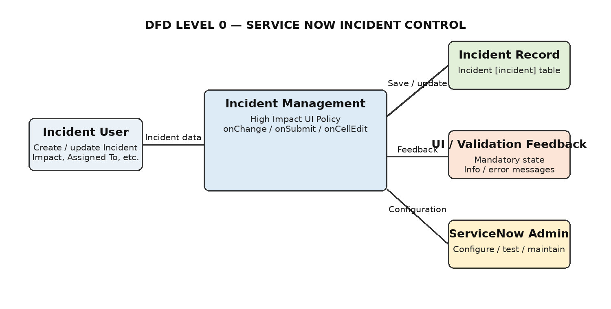
The project is platform-native: Incident users interact through the browser, ServiceNow rules process form/list events, and the Incident table stores the resulting record.

User Stories
Use the below template to list all the user stories for the product.
User Type | Functional Requirement (Epic) | User Story Number | User Story / Task | Acceptance criteria | Priority | Release
Incident User | Incident Creation | USN-1 | As an Incident user, I can create a new Incident and enter required Incident details. | Incident form accepts valid field values. | High | Sprint-1
Incident User | High Impact Control | USN-2 | As an Incident user, when I select Impact = 1 - High, I can see the configured mandatory and read-only field behaviour. | Assignment group becomes mandatory and Urgency becomes read-only. | High | Sprint-1
Incident User | Urgency Automation | USN-3 | As an Incident user, when I select High Impact, I want Urgency to be set automatically to High. | Urgency changes to 1 - High and the information message is displayed. | High | Sprint-1
Incident User | Save Validation | USN-4 | As an Incident user, I cannot submit a High Impact Incident when Assigned To is empty. | Submission is blocked and the validation message is displayed. | High | Sprint-1
Incident User | Reverse Condition | USN-5 | As an Incident user, when Impact changes from High to Medium, I want the High Impact restrictions to reverse. | Assignment group is no longer mandatory and Urgency becomes editable. | Medium | Sprint-1
Incident User | List Edit Protection | USN-6 | As an Incident user, I cannot change State directly using list editing. | Alert is shown and the edit is blocked. | High | Sprint-1
Incident User | Incident Update | USN-7 | As an Incident user, I can update a valid Incident when applicable requirements are satisfied. | Record is updated without the High Impact validation error. | Medium | Sprint-1
Administrator | Configuration | USN-8 | As a ServiceNow administrator, I can maintain the UI Policy and Client Scripts used for Incident control. | Configuration records are active, scoped to Incident and testable. | Medium | Sprint-2

User Story Traceability
Story | Requirement | Implementation | Expected outcome
USN-1 | Incident creation | Incident form | Create valid record
USN-2 | High Impact control | High Impact UI Policy | Mandatory Assignment group + read-only Urgency
USN-3 | Urgency automation | onChange Client Script | Set Urgency = High
USN-4 | Save validation | onSubmit Client Script | Block save when Assigned To is empty
USN-5 | Reverse condition | UI Policy Reverse if false | Restore normal behaviour
USN-6 | List edit protection | onCellEdit Client Script | Block State list editing
USN-7 | Incident update | UI Policy + Client Scripts | Allow valid update
USN-8 | Administration | ServiceNow configuration | Maintain and test rules

Data Entities / Stores
Primary data store: ServiceNow Incident [incident] table. User and assignment information is referenced through ServiceNow fields. No external database or external API is required in this project scope.

